Project Documentation Of
Plant Disease Detection System using Vision Transformer (ViT) and CNN Baseline

Abstract
This project develops a plant disease detection system that classifies leaf images into multiple crop–disease and healthy classes using deep learning. The system is built around a Vision Transformer (ViT) model (vit_base_patch16_224) that leverages pretrained ImageNet weights to learn rich visual representations from leaf images. A simpler Convolutional Neural Network (CNN) trained on 128×128 images serves as a baseline.
Both models are trained and evaluated on the PlantVillage color leaf image dataset (Kaggle). Images are split into train/validation/test subsets and preprocessed via resizing, normalization, and light augmentation. In prototype experiments on the validation set, the CNN baseline achieves approximately 93.0% accuracy, while the ViT model reaches approximately 91.8% accuracy, with weighted precision, recall, and F1-scores all above 0.90 for both models. The project supports SDG 2 (Zero Hunger) by enabling earlier and more accurate plant disease diagnosis and SDG 12 (Responsible Consumption and Production) by encouraging more targeted and efficient pesticide use.

- Introduction
  - Background and Motivation
Plant diseases such as blight, rust, and mildew are a major cause of yield loss and economic instability in agriculture. Diagnosis in the field is typically performed visually by farmers or extension workers, which:
- Depends heavily on expert availability and experience
- Can be slow and subjective
- Is prone to errors when symptoms are subtle or similar
Late or incorrect diagnosis often results in:
- Reduced yields and food insecurity
- Excessive or inappropriate pesticide application
- Higher production costs and environmental contamination
With the availability of large labeled datasets like PlantVillage and the increasing access to GPUs through platforms such as Google Colab, there is a strong opportunity to use Machine Learning (ML) and Deep Learning for automated plant disease detection from leaf photographs. This project aims to build such a system using a modern Transformer-based model (ViT) and a classical CNN, with a focus on agricultural applications and SDG alignment.
  - Objectives
The main objectives of this project are:
- To build a reproducible data pipeline that downloads the PlantVillage color dataset from Kaggle, performs a train/validation/test split, and applies consistent preprocessing and augmentation.
- To implement and train a CNN baseline on 128×128 images for multi-class plant disease classification.
- To fine-tune a Vision Transformer (ViT) model on 224×224 images using pretrained ImageNet weights, and compare its performance against the baseline CNN.
- To evaluate both models using accuracy, precision, recall, F1-score, confusion matrices, and ROC/precision–recall curves.
- To analyze how the solution contributes to SDG 2 (Zero Hunger) and SDG 12 (Responsible Consumption and Production).
- To produce a modular, well-documented PyTorch codebase with scripts for training, evaluation, inference, and visualization.

- Relation to SDGs
2.1 SDG 2 – Zero Hunger
The system helps mitigate crop losses by enabling timely and accurate detection of plant diseases from leaf images. This supports:
- Improved yield and food availability through early intervention
- Reduced risk of large-scale crop failure
- Better decision-making for smallholder farmers who may not have regular access to experts
By embedding the model in advisory tools, extension services can offer more consistent disease diagnosis, contributing to more resilient and productive agriculture and directly aligning with SDG 2.
2.2 SDG 12 – Responsible Consumption and Production
By distinguishing between specific diseases and healthy leaves, the system can:
- Reduce unnecessary or incorrect pesticide applications
- Encourage more targeted treatments based on accurate diagnosis
- Minimize environmental contamination and resource wastage
This leads to more efficient and sustainable agricultural production in line with SDG 12, promoting responsible use of inputs and reducing the environmental footprint of crop protection practices.

- Dataset
3.1 Source and Structure
- Dataset: PlantVillage (color leaf images)
- Source: Kaggle
- URL: https://www.kaggle.com/datasets/abdallahalidev/plantvillage-dataset
- Domain: Agriculture – leaf disease classification
The dataset contains tens of thousands of leaf images, each labeled with:
- Crop species (e.g., apple, grape, potato, tomato)
- Disease type or healthy status (e.g., Apple scab, Black rot, Late blight, Leaf mold, healthy)
The project uses the color subset only. In the project directory, the data is organized as:
Raw Kaggle download/unzip:
data/plantvillage_raw/
- Processed dataset for modeling:
data/plantvillage/
├── train/
│ ├── Apple___Apple_scab/
│ ├── Apple___Black_rot/
│ └── ...
├── val/
│ └── ...
└── test/
└── ...
Each folder under train/, val/, and test/ contains images of a single crop–disease or healthy class, enabling use of torchvision.datasets.ImageFolder.
  - Preprocessing
Preprocessing steps are implemented in utils/data_loader.py and include:
- Train / Validation / Test Split (in utils/split_dataset.py)
  - Train: 70% of images per class
  - Validation: 15% of images per class
  - Test: 15% of images per class
  - Splitting performed per class to maintain class balance in each subset.
- Image Loading and Conversion
  - Images loaded via ImageFolder and converted to RGB if needed.

- Resizing & Normalization
  - CNN baseline input size: 128×128.
  - ViT input size: 224×224 (required by vit_base_patch16_224).
  - Images converted to tensors and normalized with:
  - Mean = [0.5, 0.5, 0.5]
  - Std = [0.5, 0.5, 0.5]
- Data Augmentation
  - On the training set, a RandomHorizontalFlip() is applied to improve robustness to orientation.
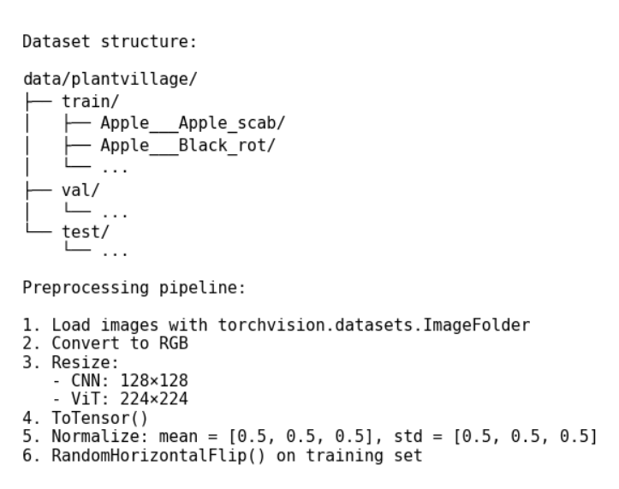
Figure 1: Summary of dataset structure and preprocessing pipeline for the plant disease detection system.

- Methodology
  - System Overview
The system includes the following components:
- Data Pipeline – Scripts to download, split, and load the PlantVillage dataset:
- utils/split_dataset.py splits color/ into train/val/test.
- utils/data_loader.py creates PyTorch DataLoaders with appropriate transforms.
- Baseline Model – CNN – A simple convolutional classifier (SimpleCNN in model.py) trained on 128×128 images.
- Main Model – ViT – A Vision Transformer (vit_base_patch16_224 via timm) fine-tuned on 224×224 images (build_vit in model.py).
- Training Scripts – train.py defines train_baseline_cnn and train_vit, encapsulating the training loop with loss computation, backpropagation, and validation.
- Evaluation & Visualization – evaluate.py computes metrics on the test set; visualize_results.py plots training curves, confusion matrices, and ROC/PR curves.
- Inference – inference.py provides a predict_image() function that loads a trained model and predicts the disease class for a single input image.
Figure 2: Overall system pipeline for plant disease detection
  - Baseline Model – Convolutional Neural Network (CNN)
- Implementation: SimpleCNN in model.py, trained via train_baseline_cnn in train.py.
- Input: 128×128 RGB images.
- Architecture:
- Feature extractor:
- Conv2d(3 → 32, kernel_size=3, padding=1) → ReLU → MaxPool2d(2)
- Conv2d(32 → 64, kernel_size=3, padding=1) → ReLU → MaxPool2d(2)
- Conv2d(64 → 128, kernel_size=3, padding=1) → ReLU → MaxPool2d(2)
- Classifier:
- Flatten
- Linear(128 × 16 × 16 → 256) → ReLU
- Dropout(0.5)
- Linear(256 → number_of_classes)
- Training Configuration (prototype):
- Loss: Cross-Entropy Loss
- Optimizer: Adam (learning rate ≈ 1e-3)
- Batch size: 32
- Epochs: 3
- Device: GPU (if available) via get_device()
This model provides a strong, easily interpretable baseline for multiclass image classification with relatively low computational cost.

  - Main Model – Vision Transformer–Based Classifier
Implemented in model.py and used by train_vit in train.py.
    - ViT Architecture and Setup
- Model: vit_base_patch16_224 from timm.
- Initialization: pretrained on ImageNet (pretrained=True).
- Final head: replaced with a linear layer outputting logits for num_classes PlantVillage classes.
Internally, the ViT model:
- Splits the 224×224 image into 16×16 patches.
- Embeds each patch into a vector and adds positional encoding.
- Processes the sequence of patch embeddings using multi-head self-attention and feed-forward transformer blocks.
- Uses a special classification (CLS) token whose final representation is passed through the classification head.
    - ViT Training Configuration
- Input size: 224×224 RGB images.
- Loss: Cross-Entropy Loss.
- Optimizer: Adam (learning rate ≈ 3e-4).
- Batch size: 16.
- Epochs: 3.
- Device: GPU if available.
The training loop logs training loss and validation accuracy each epoch. Validation accuracy in prototype runs reaches approximately 91.8%.
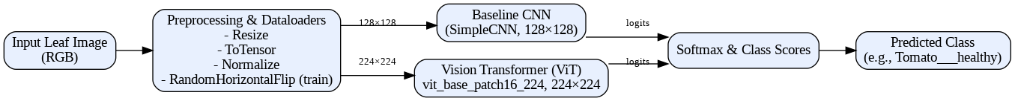
Figure 3: Vision Transformer based architecture

- Experimental Setup
5.1 Data Splits
From utils/split_dataset.py and utils/data_loader.py:
- Train: 70% of images per class
- Validation: 15% per class
- Test: 15% per class
- Splitting is stratified by class to maintain balance.
5.2 Hyperparameters
Baseline CNN – train_baseline_cnn:
- Epochs: 3 (can be extended)
- Batch size: 32
- Learning rate: 1e-3 (Adam)
- Loss: Cross-Entropy
ViT – train_vit:
- Epochs: 3 (can be extended)
- Batch size: 16
- Learning rate: 3e-4 (Adam)
- Loss: Cross-Entropy
5.3 Evaluation Metrics
For both models, evaluate.py and utils/metrics.py compute:

- Results and Discussion
6.1 Baseline vs Main Model (Validation Set)
Baseline – CNN (on 128×128 images)
(from training logs in train.py)
- Epoch 1 – Validation Accuracy: 84.35%
- Epoch 2 – Validation Accuracy: 89.20%
- Epoch 3 – Validation Accuracy: 93.00% (best)
Approximate training time: ~1 hr 49 mins per epoch on Colab GPU
Main Model – ViT (on 224×224 images)
(from training logs in train.py)
- Epoch 1 – Validation Accuracy: 84.72%
- Epoch 2 – Validation Accuracy: 90.11%
- Epoch 3 – Validation Accuracy: 91.79% (best)
Approximate training time: ~4 hrs 56 min per epoch on Colab GPU
Discussion:
The CNN baseline already achieves strong performance with relatively low training time and resource usage. The ViT model, while more expressive and leveraging pretrained knowledge from ImageNet, requires significantly more computation per epoch and, in these initial runs, attains slightly lower validation accuracy. Both models achieve high weighted precision, recall, and F1-scores (>0.90), according to the classification reports saved in artifacts_baseline.pkl and artifacts_vit.pkl.
Table 1: Inference on a Tomato healthy Test Image
Model | Input Sample | Predicted Class | Confidence (%)
Baseline CNN | Tomato leaf (test image) | Tomato healthy | 96.51
Vision Transformer (ViT) | Tomato leaf (same test image) | Tomato healthy | 77.32
Both models correctly classify the leaf, with the CNN showing higher confidence on this instance. Overall, the results suggest that a well-tuned CNN can be highly effective on this curated dataset, while ViT offers a more advanced architecture that may outperform the CNN if given more epochs, stronger augmentation, and further hyperparameter tuning.

- Technology Benefits
- Advanced Architectures: Demonstrates the practical use of both CNNs and Vision Transformers for agricultural image classification, satisfying the requirement to use Transformer-based models in a real domain.
- Modularity: The codebase is modular, with separate files for data loading (utils/), models (model.py), training (train.py), evaluation (evaluate.py), visualization (visualize_results.py), and inference (inference.py), making it easy to reproduce experiments and extend the system.
- Transfer Learning: Integrating pretrained ViT from timm shows how transfer learning can be applied to domain-specific problems like plant disease detection.
- Reusability: Utilities such as dataloaders, metric functions, and plotting scripts can be reused for other computer vision projects in agriculture (e.g., fruit quality grading, weed detection).

- Business and Practical Benefits
- Improved Disease Diagnosis: Farmers and agronomists can receive quick, data-driven indications of likely plant diseases by simply capturing leaf images.
- Cost and Risk Reduction: Early and more accurate disease detection reduces the risk of severe outbreaks and lowers the need for broad, preventive pesticide spraying.
- Scalability and Integration: The models can be integrated into:
- Mobile or web applications for farmers
- Dashboards for extension workers or agronomists
- Advisory tools used by government agencies and NGOs
- Adaptability: The system can be fine-tuned with additional local images to adapt to new crops, regions, or emerging diseases.

- Project Timeline
Table 2: Actual / Approximate Timeline
Phase | Key Tasks | Approx. Hours
Data Setup & Exploration | Configure Kaggle API; download PlantVillage dataset; inspect class distribution and image quality; implement dataset splitting and PyTorch dataloaders | 6–8
Baseline Model Implementation | Implement CNN baseline architecture; train model; perform basic evaluation; generate accuracy and loss plots | 6–8
ViT Integration & Training | Integrate Vision Transformer (ViT) using timm; fine-tune pre-trained model; monitor training metrics; manage computational and memory constraints | 10–12
Evaluation & Visualization | Run final test evaluations; generate confusion matrices; plot ROC and Precision–Recall curves; compare learning curves of CNN and ViT models | 6–8
Documentation & Presentation | Write project documentation; prepare README; create slide deck; develop demo script or recorded presentation | 8–10

- Tech Stack
- Language: Python 3 (Google Colab environment)
- Frameworks & Libraries:
- PyTorch, torchvision (core deep learning and data loading)
- timm (Vision Transformer implementation)
- scikit-learn (metrics, ROC/PR computation)
- NumPy, Pandas (data handling)
- Matplotlib, Seaborn (visualizations)
- tqdm (training progress bars)
- Kaggle (dataset download)
- Development Tools:
- Google Colab (primary training and experimentation platform)
- Git + GitHub (version control, collaboration, and submission)

